How to look up appointment data to assist with staff evaluations


Step 1: Use the navigation ribbon on the left side of the screen to navigate to the Reporting tab by clicking on the icon.
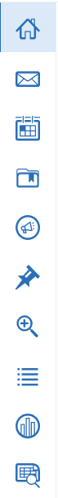
Step 2: Click on Standard Reports.
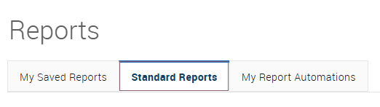
Step 3: Scroll down or search for the Appointment Summaries report.
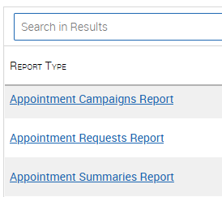
Step 4: Use the Data Filters to narrow down your search parameters. Be aware that if you include a long range of dates, the report could take several minutes to run.
- You can search for more than one location at a time.
- You can filter based on student characteristics, such as students on probation, or students in a specific major.
- You can filter by a date range (Scheduled Start Date is recommended).
- You can also keep your search quite broad and then use Excel to filter the results.

Step 5: After determining the filters for the report, click Run Report.
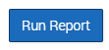
Step 6: Once the report is finished loading, click on the button with the three lines (Actions) Export. There are additional actions you can take for data analysis within the reporting platform.
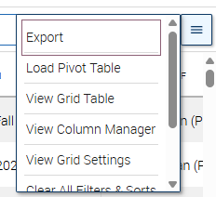
Step 7: The report will download as a .csv file.
Step 8: Open the file and view the data. Some examples of questions you can answer with this report:
- How many appointments were scheduled/completed at this location during a given date range?
  - How many appointments by staff member?
  - How many cancels/no-shows, and did those rates vary by staff member?
  - How much time was spent on student appointments (note: time reported depends on the time listed in the appointment summary).
  - If your staff members have been updating the “meeting type” field, you can see how many appointments were online vs email vs in person.
- How many campaigns did each staff member have open during this time period?
  - How many appointments were scheduled/completed as part of each campaign?
- Are there any non-cancelled appointments without summary reports?
  - When were summary reports submitted relative to the appointment time?
  - Does the content of the summary reports match the expectations in the BoilerConnect documentation guidelines?
- How many appointments took place with students in a given category (e.g., probation, first generation), classification, or major?
  - Categories are all combined into one column so you would need to use conditional formatting to highlight cells with the text you’re looking for and then sort by cell color.
  - If your team meets frequently with students outside your own college or department, you could search to see which students your team is spending the most time with from other majors.

